Text-mining Assignment Submission Cover Sheet

Assignment Title | Final Assignment – Text Mining Analysis
Module | DATA 9900 - Data Mining
Student Name | Eamonn Kelly (student number = D24127620)

Data Understanding and Preparation (20 points)
- Definition of Problem
Identify Negative and Positive sentiment feedback from text based review data and rating values, to improve services, offerings and ultimately improve the business.

Th data set was sourced from Kaggle - dataset - Kaggle - McDonalds reviews - https://www.kaggle.com/datasets/nelgiriyewithana/mcdonalds-store-reviews
- Data Preparation
Include details of any data cleaning, transformations, data enrichment, feature engineering, feature reduction, etc

    - Data shape = (33,396, 10) > 33, 396 rows of data and 10 columns, parameter variables
    - Column analysis
  - 'reviewer_id'
    - dtype = int - numeric, unique ID, primary key
    - discrete data
  - store_name
    - dtype = python object - str class - text, no variation in data.
    - categorical data
    - 71 rows with non ascii character present, same type for each row = ["McDonald's" "ýýýMcDonald's"]
    - we will fix this.
    - column data won't hold much value in later analysis work as contains no variation.
  - ‘store_address’
    - dtype = python object - str class - alpha numeric, need to split out
    - categorical data
    - 1 non-ascii characters present -
    - 660 rows with non ascii character, same type for each row = '2476 Kalï¿½ï¿½ï¿½ï¿½ï¿½ï¿½ï¿½ï¿½ï¿½ï¿½ï¿½ï¿½ï¿...''
    - will not modify as will address with 'store_id' solution
  - 'category'
    - dtype = python object - str class - text, no variation in data.
    - categorical data
    - of the type of restaurant
    - only 1 type, ["Fast food restaurant"]
    - again, column won't hold much value in later analysis work as contains no variation.
  - 'latitude' -
    - dtype = float - numeric (decimal, pos and neg)
    - continous data
    - may be useful later for spatial analysis if possible
  - 'longtitude'
    - dtype = float - numeric (decimal, pos and neg)
    - continuos data
    - may be useful later for spatial analysis if possible
  - 'ratings_count'
    - dtype = python object - str class - numeric
    - discrete data
    - number of reviews per store at the time the particular review we have in our data was posted,
    - have a lot of repeated values as the number remained the same when review was posted.
    - there are 51 unique values but there are only 40 stores.
    - Not sure how reliable a metric this is ...
  - 'review'
    - dtype = python object - text based content, str type.
    - unstructured data
    - contains actual review text for the store
    - All appears to be english langauge
    - Non-ascii chracters present, many differnt types
    - 3037 rows containing some form of non-ascii character.
    - Some appear to be apostrophes i.e. 'Didnï¿½ï¿½ï¿ïï¿½...'', 'McDonaldï¿½ï¿½ï¿½½ï¿...'', 'Doesnï¿½ï¿½ï¿½ï¿½ï¿½ï¿½ï' and thus retain meaning
    - as such we will not modify or tr fix. wil leave as is and preserve meaning as is.
    - onw row contains '?' character as placeholder value. This adds no data/meaning to dataset. ASs such will remove this row as is just noise.
  - 'rating'
    - dtype - python object - alphanumeric content
    - categorical - ordinal data
    - contains numerical star rating for the store
    - will strip out rating number to separate standalone column , 'star_rating_num' so can use more easily.
    - Missing Values
    - Present in Longitude and Latitude columns only
  - 660 in each
    - No Duplicate entries
    - No ‘null,’, ‘unknown’, 'na’, ‘none’, present in the data.
    - 40 different store addresses
    - Reviewers
  - 33,396 unique users
  - 22,285 unique rows of feedback.
  - Either some reviewers left no feedback or we have identical/near identical feedback.
  - Requires further analysis
    - Numerical Data
  - Is spatial data and unique user IDs.
  - of limited use for analysis directly at this stage
    - Encoding issue:
  - tried different coding types during import of csv data i.e. 'utf-8', 'latin1', 'cp1252'
  - none addressed corrupt characters issue identified earlier i.e. many character types 'ï¿½' among others
  - Ended up using 'ISO-8859-1' so could import without error and not lose amy more data
  - This is most likely due to incorrect encoding used during initial scraping, storage or transfer of data to csv. Unable to recover original characters.
  - Will leave as is to preserve review text meaning as is.

    - Actions:
  - 'review_time'
    - mixture of alpha numeric data and mixture of relative timelines ie.. '23 Hours ago', '1 day ago', '6 months aga', '10 years ago'
    - We have data from < 1 day ago to 10 years + ago. These do not have the same validity and as such need to categorise to be able to easily identify and distinguish data relevance.
  - 'rating'
    - mixture of alphanumeric data i.e. '1 star', '2 star', etc
    - create numeric only rating so can more easily manipulate, count, aggregate etc
  - 'store_address'
    - Split out Address into its component parts, allow us more easily manipulate, aggregate and display, i.e. categorise per state, etc
    - ‘street_number’, ‘street_name’, ‘city’, ‘state’, ‘zip_code’, ‘country’
  - 'store_address'
    - Create unique 'store_id'
    - plots of stores are very busy as the store_address is long mixed string,
    - create a unique ID for each store which will be easier to display during plotting and aggregate, groupbyy later if we need.
    - ‘reviewer_id’ will remain primary key in the data, as it is unique per row, so we have per row reviewer feedback
  - 'store_name'
    - fix single cell corruption
  - 'review'
    - remove row containing just the '?' character as a review. It is placeholder review, contains no data, only noise in our dataset.
- Post cleaning exploration state
  - Shape = 33,395, 19)
  - New derived columns
    - ‘review_relative_time’ - derived relative time column per review
    - ‘store_id’ – unique store if value - per store
    - ‘star_rating_num’ – derived – numeric only value of rating
    - ‘street_number’ - derived from address
    - ‘street_name’- derived from address
    - ‘city’- derived from address
    - ‘state’- derived from address
    - ‘zip_code’- derived from address
    - ‘country’- derived from address
- Missing data
  - total = 4330
  - is consistent with the data we obtained originally in the csv and tied into store details, lat, long, ciy, state, zip_codes and street number with 1030.
  - No missing ‘review’ data
  - No random missing values
Text Preprocessing Pipeline

Prior to feature extraction and modelling, review text was preprocessed to standardise input, reduce noise, and improve model performance while maintaining interpretability.

All reviews were lowercased to avoid duplicate tokens caused by case differences. Punctuation and non-alphabetic characters were removed, as they do not typically convey sentiment information in this context. Text was then tokenised into individual word tokens suitable for vectorisation.

Stopwords (e.g. “the”, “and”, “is”) were removed to reduce dimensionality and focus the models on sentiment-bearing terms. Lemmatisation was applied instead of stemming to reduce words to their base form while preserving semantic meaning (e.g. “running” to “run”). This choice supports later interpretability, particularly for log-ratio analysis and explanation of model outputs.

Overall, this preprocessing pipeline balances noise reduction, computational efficiency, and interpretability, aligning with the CRISP-DM emphasis on well-justified data preparation.

2. Data Visualization and Exploration (20 points)
- Data Exploration & Descriptive Analytics
Part 1) Number of stores per state.
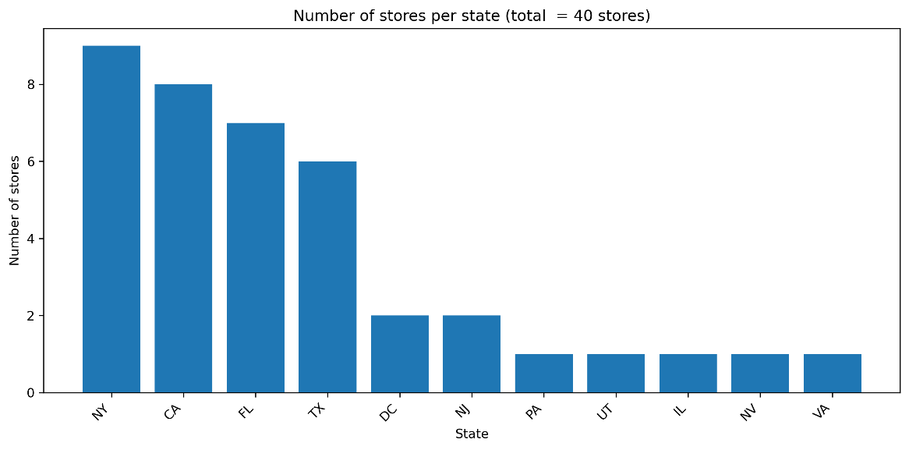
Part 2) Store performance by mean, median and cumulative data
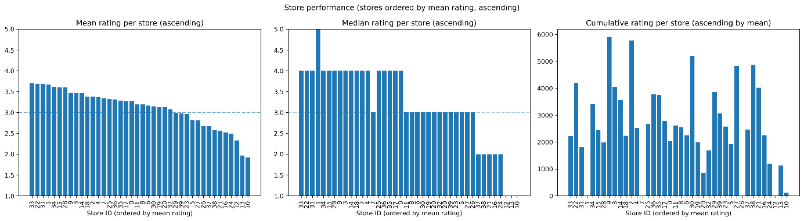
- A quick overview comparison plot of all three, mean, median and cumulative
- store_id numbers - 31, 32, 31 are best performing, agrees broadly across mean and median
- Does not agree with cumulative however.
- Low sample count results in low rating performance. Perhaps put in place a metric for minimum number of reviews.
- Mean appears to provide a more stable calculation of performance. It takes account of all data and addresses variations due to sample size.
- Median provides a stable overview but appears less sensitive to gradual shifts in ratings, and a lot appear neutral at 3, or one step above or below. It displays more step wise behaviour.

Part 3) Tabular comparison of to 5 stores and worst 5 stores
- ======= top 5 stores ==============

- top 5 stores = mean_rating median_rating review_count cumulative_rating
- store_id
- 33 3.70 4.0 602 2226
- 22 3.69 4.0 1140 4209
- 31 3.69 4.0 490 1807
- 1 3.67 5.0 3 11
- 34 3.62 4.0 943 3409
- ======= worst 5 stores ==============

- top 5 stores = mean_rating median_rating review_count cumulative_rating
- store_id
- 10 1.92 1.0 60 115
- 13 1.97 1.0 570 1124
- 12 2.33 1.0 3 7
- 24 2.49 2.0 481 1199
- 16 2.53 2.0 890 2248
- Overview of Results
- 33, 22, an 34 are performing well. Have relatively high rating count and above average rating numbers.
- 13, 16 and 24 are not performing well. Have relatively high rating count yet low mean_rating
- Store 10 haas a relatively low rating count, so more dat would be required to make a proper assessment of it, but initial feedback indicators are that it is not performing to a high level
- stores 1 and 12 have very low sample count, so this result unreliable for those stores
- As per earlier, low sample counts are affecting performance assessment.
Part 4) Number of Reviews per store
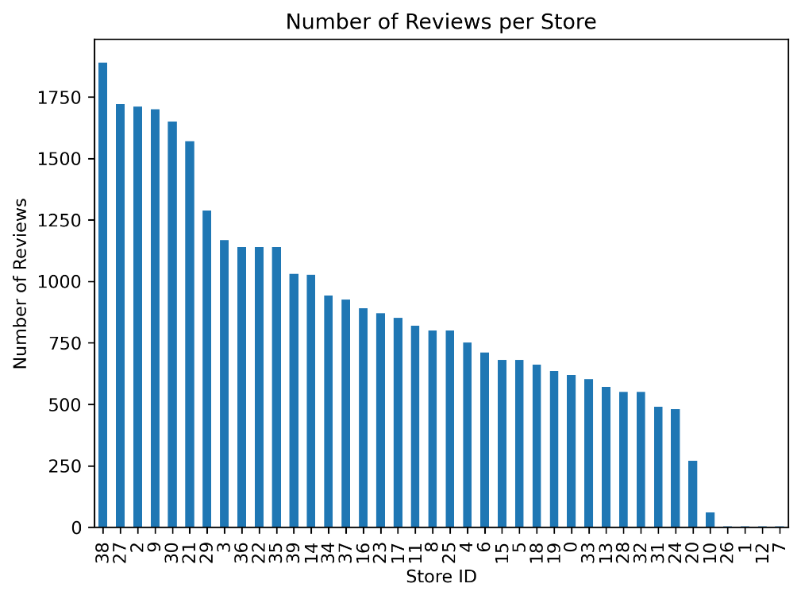
- Bg difference in volume of reviews per store ranging from 1750+ to 1.
- A store with an average rating of 3.5 and 500 reviews has less weight as an accurate measure to a store with an average of 3.1 and 1500 reviews.
Part 5) Yearly rating trends for ratings and review volume
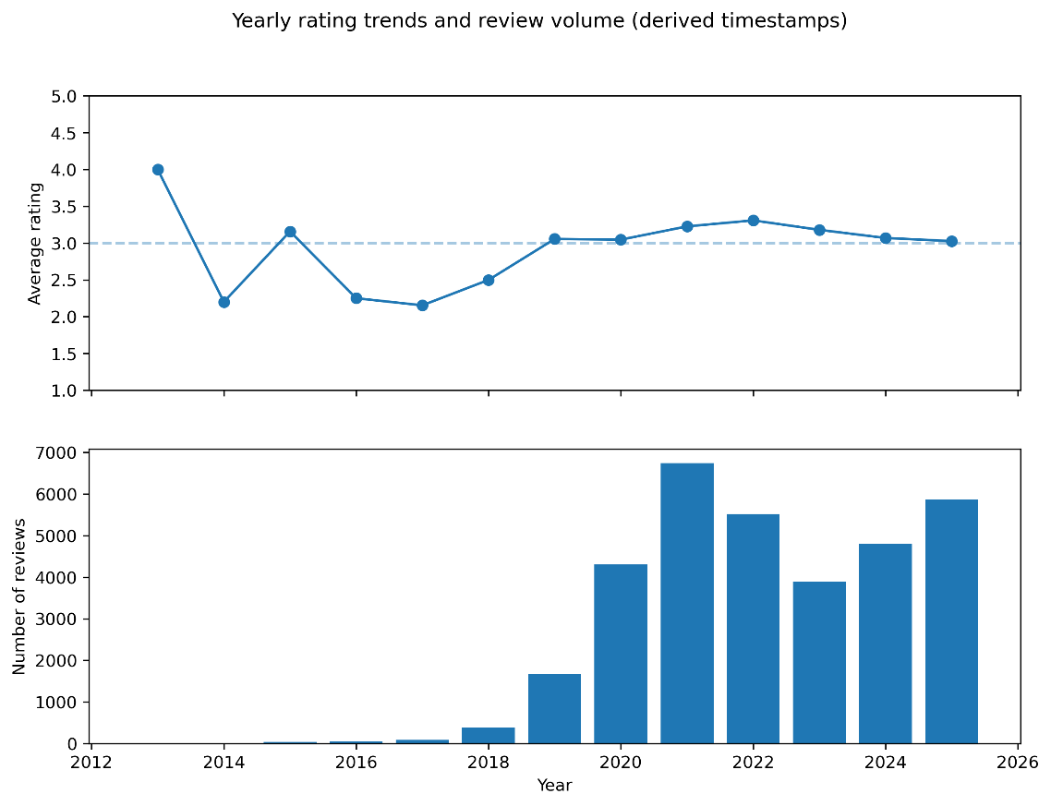
- Average rating dropped from approx 2017 to 2019- but these have low sample counts.
- Has hovered in or around neutral, i.e. 3.0 since then
- Additional time series plots were removed from the notebook as there were limitations in there usefulness.
- These derived time values have their limitations and have accumulations of data around specific dates i.e. Dec every year dure to how we calculated the time.
- we will not focus on time based data for further analyse as a result as limited data available and insight available from it.
- from 2012 to 2019 have very little review data
- Most data is from 2020 onwards
- Feedback volume is skewed to the right (positively skewed)
Par 6) Likert plot of customer ratings by store
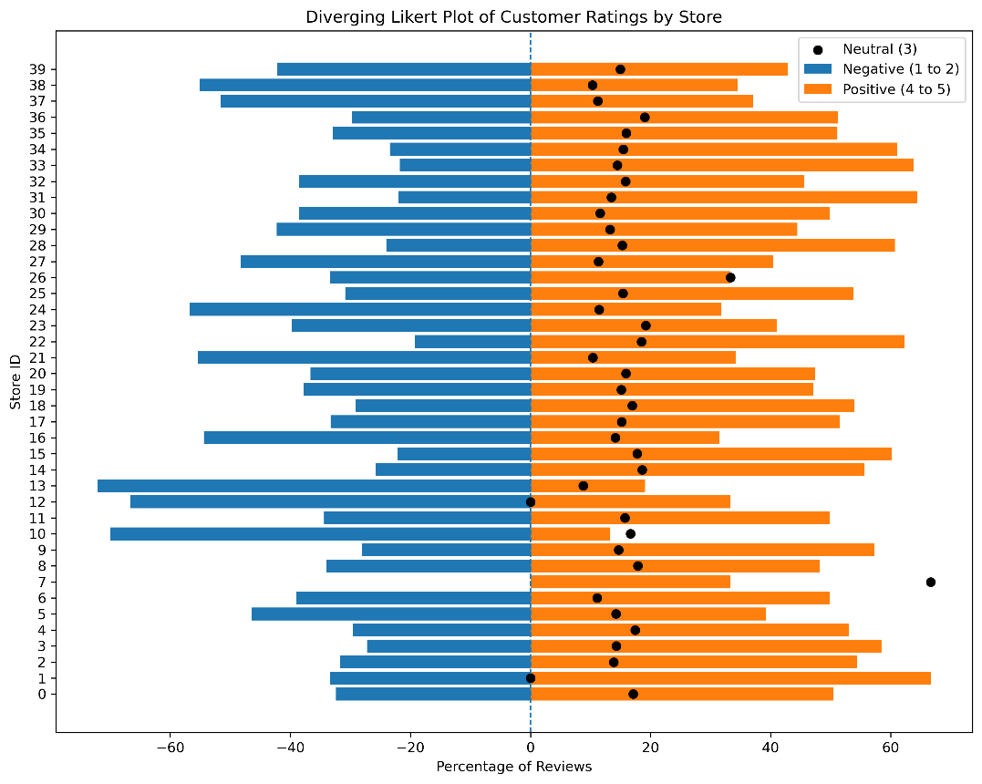
- Diverging Likert plot helps visualise the distribution of positive, negative and neutral reviews to provide an overall sentiment per store.
- Rating values were aggregated at 1+2 = negative, 4+5 as positive and 3 = neutral.
- Orange bars to the right hand side are positive review
- Blue bars to the left hand side are negative reviews
- Black dots on bar are number of neutral reviews
- ‘store_id’ = 7 - looks like anomaly
      - has 0 negative / 2 neutral / 1 positive review = > as total pos/neg/neutral must = 100% = > neutral = 66.6%
      - this is a result of a small sample size.
- Plot provides more direct and complete performance rating in comparison to performance rating using mean, median or cumulative
Part 7) Wordcloud of word frequency
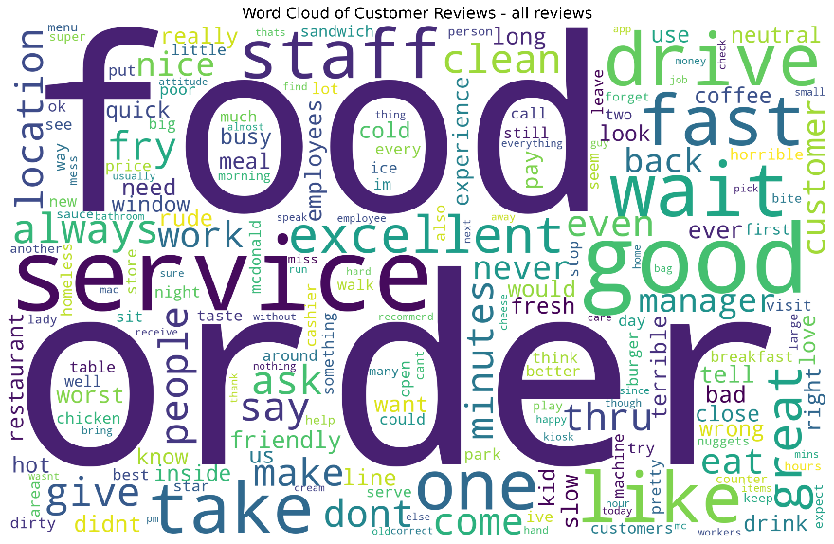

- count of frequencies of words present gives us bag of words
- frequencies were visualised where size represent proportion of occurrence in reviews
- some example positive words are 'good', 'great', 'excellent', 'friendly', 'clean'
- some example negative words are 'bad', 'worst', 'rude', 'terrible', 'cold', 'mess'
- These frequencies were visualised using a word cloud, where word size is proportional to occurrence frequency after preprocessing and stop-word removal.
- Can clearly see some words could be either positive or negative, depending on context such as rating value. There no implied sentiment in them directly.
Part 8) Positive and negative reviews top terms
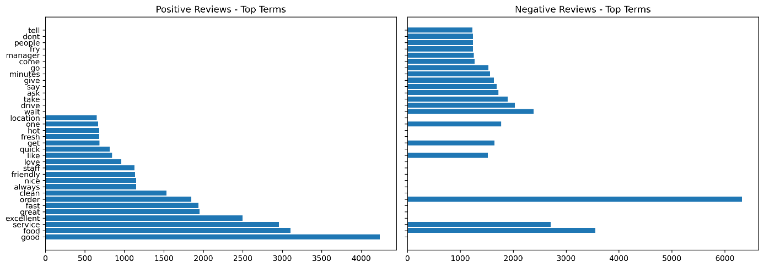
- view of the most influential words in the corpus by frequency
- positive words i.e. 'good', 'excellent', 'fast',
- negative words i.e. 'worst', 'rude', 'slow', 'wrong',
- neutral words which don't add sentient but are present in both positive and negative word lists i.e. 'food', 'service', 'order'
- sentiment appears to come from items such as ‘speed’, ‘cleanliness’, ‘staff behaviour’
- Confirms review data has valuable insight and is not random, and can build more sentiment analysis from it.
- 'food' and 'service' are the top occurring words in both positive and negative reviews, the key word alone will not indicate type of feedback, we need to star rating to apply that context.
Part 9) Document Embedding Visualisation using UMAP

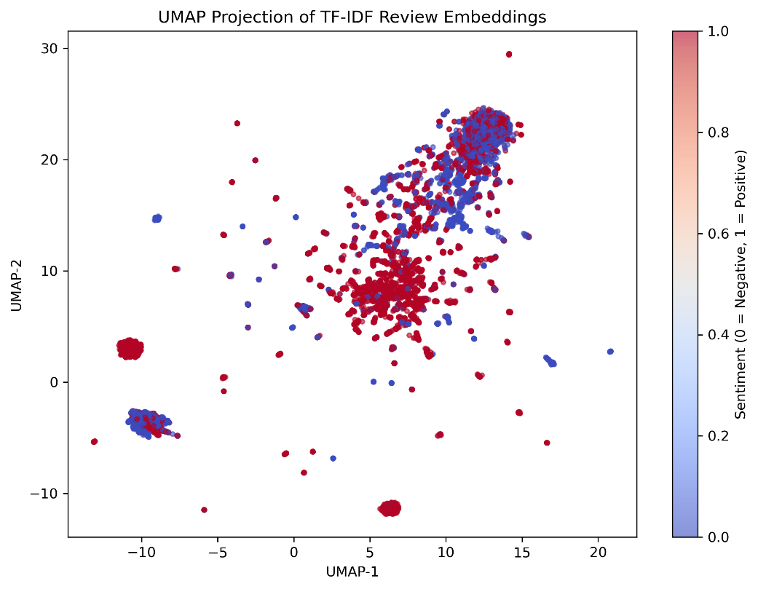
- The UMAP projection of TF–IDF review embeddings reveals the structure within the review corpus when coloured by binary sentiment.
- was configured with 15 nearest neighbours (n_neighbours=15), min distance = 0.1(min_dist-0.1), and two output dimensions
- Positive and negative reviews show partial clustering,
- shows that sentiment information is captured within the high-dimensional TF–IDF feature space.
- Several dense regions are visible where one sentiment class dominates,
- There is also overlap between classes, particularly in the central region of the plot.
      - This likely reflects reviews containing mixed sentiment, neutral language, or context-dependent terms (e.g. words such as “food” or “service”
- Small number of isolated clusters and outliers are also visible.
      - These may correspond to unusually short reviews, highly repetitive phrases, or reviews containing uncommon vocabulary, all of which can lead to distinct TF–IDF representations.
- Each dot in the UMAP plot = one review’s TF–IDF embedding
- Overall, the plot supports the quantitative modelling results i.e. while sentiment is not perfectly separated there is sufficient structure for linear classifiers to achieve predictive outcomes.

- Identification of the most important variables
- High Analytical Value
  - 'reviewer_id' - our primary key, allows for unique reviewer per row data, prevents duplication and allows reviewer aggregation.
  - 'review' - contains actual review text. essential for further analysis and NLP tasks.
  - 'star_rating_num' - essential to provide context and sentiment for text review data.
  - 'store_id' - allows for review per store and comparisons between stores
These variables are retained in the dataframe as they are core to future analysis

- Limited Analytical value
  - 'review_relative_time' - derived time values, as such limited use for detailed proper time series analysis. Encountered issues around clustering of times around December, so accuracy is questionable outside of yearly time frame.
  - 'lattitude' and 'longitude' - potential value if can include soe spatial/geolocatin analysis.
  - 'city' - medium value to aggregate data by city
  - 'state' - medium value to aggregate data by state
These variables while they are not included in initial modelling dataframe in stage 3, they are available in case of future usage requirements

- Low Analytical value
  - 'store_address' - in its current form not a huge amount of analytical value. parsed it out into its constituent components which may have some value.
  - 'street_number - limited value as have 'store_id' as unique id for stores now. May provide some use later
  - 'street_name' - limited value as have 'store_id' as unique id for stores now. May provide some use later
  - 'country'- no analytical value. No variation in the data, just a single data value.
  - 'category' - no analytical value. No variation in the data.
  - 'store_name' - no analytical value. No variation in the data.
  - 'rating' - low analytical value now as mixed alphanumeric and have derived 'star_rating_num' column now.
  - 'review_time' - low analytical value now as mixed alphanumeric and have derived 'review_relative_time' column now.

These variables are removed from the dataframe o reduce noise and dimensions.

- Determination of how valuable columns was evidence based.
  - assessment of dtypes and variable meaning
  - numerical and categorical data exploration
  - quantity of data per column
  - variety of data (number of unique of values)
  - level of corruption present
  - missing values
  - plots and statistical analysis
  - where data wasn't clean, derived new columns were created which were more easily usable in analysis such as 'store_id' and 'star_rating_num'

3. Model Building and Evaluation (20 points)
- Details of Algorithms & Configurations
Part 1) Words most associated with review sentiment
Crate a more targeted corpus to allow determine sentiment. Have a more targeted corpus per pos and neg reviews is key to getting accurate results in our modelling. This step is essential.
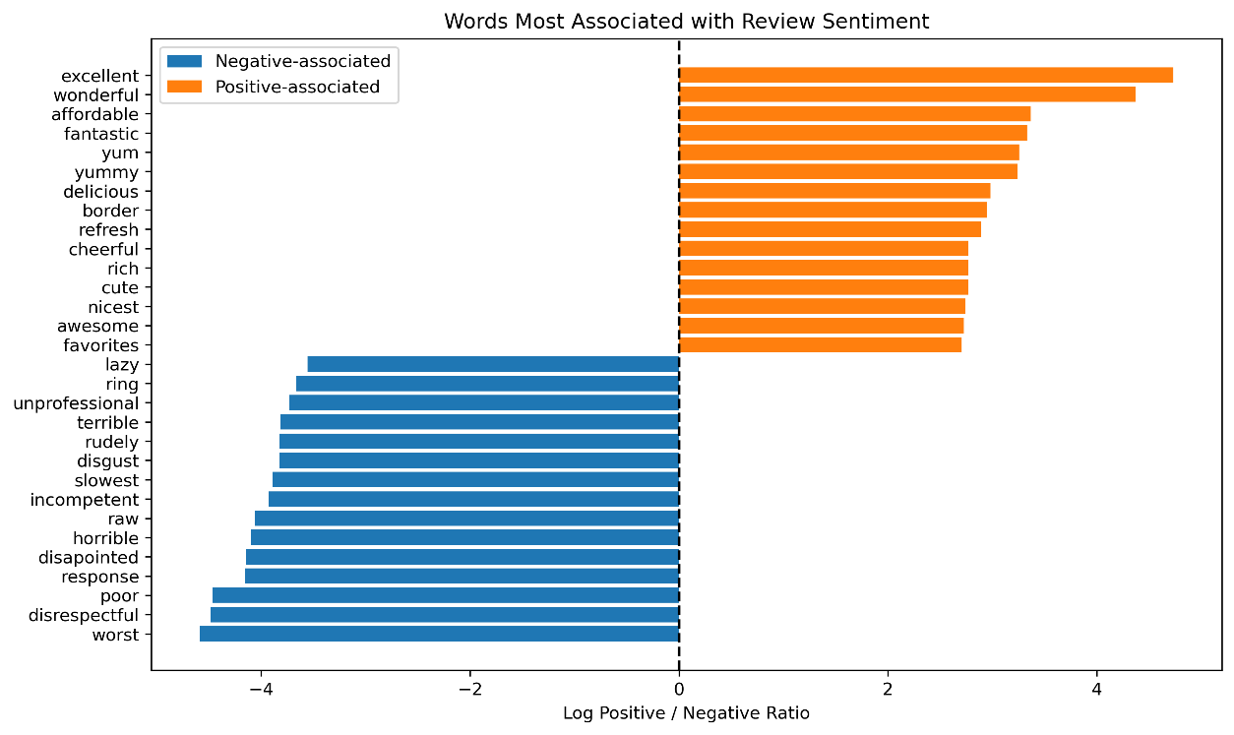
    - A log ratio analysis used to identify exclusively positive words and exclusively negative words
    - negative words drive complaints
    - positive words drive customer satisfaction
    - '4.5'to '0' = word appears in negative reviews. The higher the value the more associated with negative reviews the word is. This is a relative number
    - 0 = word appears equally in both positive and negative reviews i.e. 'food', 'order'
    - '0' to '4.5' = word appears in positive reviews. The higher the value the more associated with negative reviews the word is. This is a relative number
    - Some words imply specific actions such as staff behaviour, customer service, service times, food quality, cost
    - customer service or staff behaviour appears to be one of the biggest drivers of customer disastisfaction with words such as 'disrespectful', 'response', incompetent', 'slowest', 'rudely' , 'unprofessional', 'lazy' appearing strongly in the negative review words.
Part 2) Convert the data to binary sentiment analysis i.e. positive or negative 1 or 0
‘’’py
# keep only negative (1–2) and positive (4–5)
mask = y_raw != 3
X_texts = X_texts[mask]
y_raw = y_raw[mask]
# binary sentiment: 1 = positive (4–5), 0 = negative (1–2), 3 is removed
y = (y_raw >= 4).astype(int)
==== y value counts - class distribution =====
star_rating_num
1 16061
0 12516
Name: count, dtype: int64
==== y unique values =====

Unique labels: [0 1]
‘’’
    - 0 = negative reviews, which is 1 and 2 stars
    - 1 = positive reviews, which is 4 and 5 stars
    - 3 = neutral has been removed
    - binary values now present in dataset
- had 5 values in dataset, ratings 1 to 5, but changed to binary sentiment

Part 3) Model selection and configuration settings
All models used were liner classifiers, so they suit the dataset and we can compare
- Logistic regression
  - good for text classification and intepretability-
  - creates co-efficients per word which can check fi we need for a particular outcome
- Naïve Bayes
  - commonly used for word frequency data
  - standard probabilistic output
- Linear SVM
  - doesn't use probability modelling like others
  - output decision scores rather than probabilities
- GD Logistics
  - scalable linear model

Non linear models such as decision trees, Ramdon forest , Neural Networks etc have dependencies between features i.e. word A only matters if word B is present, and words can change sentiment depending on combination i.e. good service vs bad service for example. which is not present in our dataset, so these are not good candidates.

As they are also all linear models we also can compare easily and directly across the models.

Configuration
- Train/Test plit
- ‘test_size = 0.2’ (standard size – 80%/205 split. Did not modify)
- ‘stratify=y’ (preserves class ratio)
- ‘random_state =42’ (just a random value to ensure same start point each time (the answer to life...))
- text feature extraction
  - used tf-idf vectorization for all
  - used same values for all models to ensure consistency in results comparison
- ‘max_features=1000’ (limit dimensionality for speed)
- ‘min_df=5’ (removes very rare words (typos, on-off tokens etc)
- ‘max_df=0.7’ (removes very common terms appearing in > 70% of rows)
- Cross-validation
  - stratifiedKfold
    - ‘n_splits = 5’ (standard value for number of folds. Did not modify)
    - ‘shuffle = true’

- Model Performance Metrics & Evaluation of Results
Present the performance metrics used to evaluate the models. Compare the results, highlighting the strengths and weaknesses of each model.
Part 1) ROC Curves
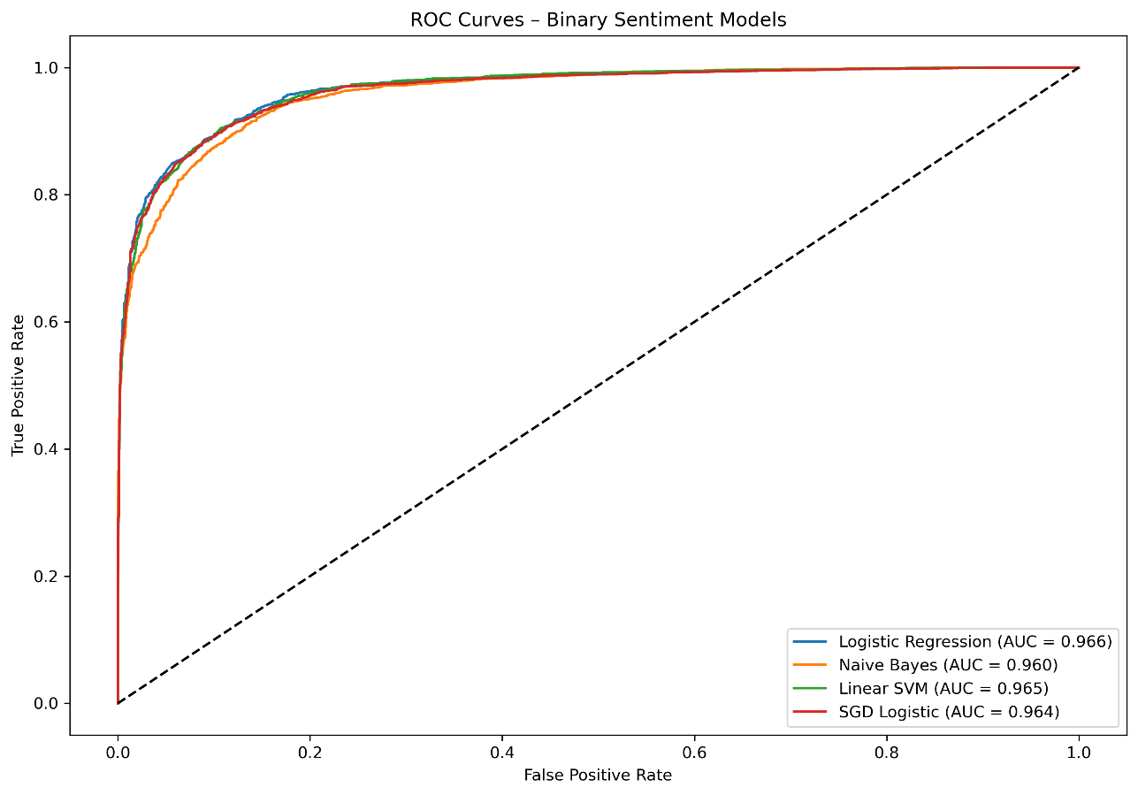
Part 2) Confusion Matrix Results
========================================

Confusion Matrix Logistic Regression
Rows = True labels, Columns = Predicted labels
Pred 0 Pred 1
True 0 2284 219
True 1 387 2826
========================================

Confusion Matrix Naive Bayes
Rows = True labels, Columns = Predicted labels
Pred 0 Pred 1
True 0 2252 251
True 1 404 2809
========================================

Confusion Matrix Linear SVM
Rows = True labels, Columns = Predicted labels
Pred 0 Pred 1
True 0 2257 246
True 1 356 2857
========================================

Confusion Matrix SGD Logistic
Rows = True labels, Columns = Predicted labels
Pred 0 Pred 1
True 0 2304 199
True 1 423 2790
Part 3) Precision, recall and F1 Results
===== Logistic Regression =======
Precision: 0.928
Recall: 0.880
F1 Score: 0.903

===== Naive Bayes =======
Precision: 0.918
Recall: 0.874
F1 Score: 0.896

===== Linear SVM =======
Precision: 0.921
Recall: 0.889
F1 Score: 0.905

===== SGD Logistic =======
Precision: 0.933
Recall: 0.868
F1 Score: 0.900
- Model Choice Analysis
- Minimise FPs = SGD Logistic
- best Balance = Linear SVM
- Performance = Logistic Regression
- Interpretability = Logistic Regression
  - i.e. how explainable is the result i.e why did we get a predicted outcome = Logistic regression uses co-efficients for each word we can access easily enough.
- If minimizing False Positives is the most important goal, SGD Logistic is the best model choice. This would depend on what data we are looking for and what action may be taken off that data i.e. food cleanliness issue is flagged and food safety has to be undertaken immediately to prevent illness in a restaurant.

- This would require further business discussion about how the feedback model would be used before a final decision is taken.

- If overall performance and interpretability is important to the business, Logistic Regression may be the best model choice. i.e. a staff member is accused of an action in feedback, how was that flagged as an issue? or we need traceability in our predictions.

- Again this is a business discussion before a final decision can be taken.

4. Advanced Techniques and Analysis (20 points)
- Advanced text-mining techniques applied to the dataset

Part 1) Standardise 'review_time' to an anchored date of today to provide a **relative** timeframe for the review data
- Time series data was not easily usable in its acquired form
- generated a ‘relative’ derived datetime based off todays date and a delta between today and the date data was acquired as extrapolated from the limited data we had
- Performed feature engineering deriving temporal data from minimal time date string data.
- Allowed for analysis per time to a certain extent and assessment of reviews and volume of reviews over time.
- This did not allow more broad time series analysis however
- The review data was calculated from today’s date, thus all years have a month of December, thus leaving any monthly data un-attainable.
- However we were able to gain some insights into yearly review data and sentiment over time per year.
- Further manipulation would be required to enable proper time series analysis of sentiment.

Part 2) Likert Scale Analysis (Orindal modelling of data)
- Treated ratings as ordinal sentiment, not numeric means, median or sum values.
- Performed negative / neutral and positive aggregation
- Performed percentage normalisation per store
- Provided for comparative sentiment analysis per store in divergent plot

Part 3) Log ratio comparison to identify words associated with positive and negative reviews and plot results
- Used comparative statistics to identify discriminative terms
- Log ratio comparison was applied to the dataset to identify words which are disproportionately associated with negative or positive reviews.
- Provided access to sentiment drivers which we could make available to our models, beyond mean, median and sum metrics.
- An Important part in obtaining acceptable results in modelling
Part 4) 4.1 Clustering of review Embeddings using K-means
- To complement the supervised sentiment models performed earlier, unsupervised clustering is applied here to explore whether reviews naturally group by sentiment without labelled data
Silhouette Score (K=2) = 0.099

- The K-Means clustering produced a silhouette score of 0.099 for k=2
- This indicates a weak to moderate cluster separation suggesting that while structure exists within the review embeddings, the clusters are not strongly distinct.
- Customer reviews often contain mixed sentiment, neutral language, or context-dependent terms (e.g. “food”, “service”) that appear in both positive and negative reviews.
- As a result, TF–IDF representations naturally overlap in feature space, limiting the effectiveness of purely unsupervised clustering.
- This finding aligns with the earlier UMAP visualisation, which showed partial separation between sentiment classes but substantial overlap.
- Together, these results indicate that unsupervised clustering alone is insufficient for accurate sentiment classification, and that labelled data is required to achieve strong predictive performance.

- These observations support the use of supervised linear classifiers in later stages of the analysis, which are able to leverage subtle but consistent differences in word usage to separate sentiment classes more effectively than unsupervised methods

- Comparison with other Research & Reflections
Compare your results to at least three other researchers (maximum of five) who used the same data set. What lessons did you learn from doing this? How can your work be improved? Did you include any improvements in your work and what impact did it have?
- Aspect based sentiment analysis
  - Attempts to apply aspect based sentiment analysis, with sentiment based on specific columns if data i.e. service, cleanliness, food etc
  - Using transformer based language models such as LLaMa
  - Provides more granular insight into text sentiment
  - He wasn't successful, which may demonstrates that there can be some complexity in extracting aspect level sentiment from short, informal review text.
  - Our study focussed on overall binary sentiment, and that decision was driven by the nature of the dataset.
  - The comparison highlights that linear models combined with TF–IDF features are effective for global sentiment classification, but may be insufficient for aspect-based tasks without additional engineering,
  - Promising area for future analysis, it is an avenue we could target with some modification i.e.

- Store level sentiment
  - https://www.kaggle.com/code/heshanijayasuriya/sentiment-analysis-for-mcdonald-s-store-reviews
  - Study performed store level sentiment aggregation
  - Displayed the stores spatially on a map using longitude and latitude data
  - Caried out in R using ‘map’ library
  - Did not calculate a sentiment score per store however.
  - The availability of ‘store_id’, ’latitude’, and ‘longitude’ data indicates an opportunity to extend our analysis by incorporating store-level sentiment scoring and spatial visualisation in future iterations.

- Use of Transformer based language models
  - https://www.kaggle.com/code/yorkyong/aspect-based-sentiment-analysis-llama-ft
  - Several examples using transformer based models.
  - Allows for the capture of relationships between all words in sentences simultaneously.
  - While powerful there is a trade off with complexity and interpretability.
  - It would not be appropriate for our dataset under a binary sentiment analysis scenario, our project achieved 96% ROC AUC performance without the uae of transformers.
  - However with a larger dataset or more complex data, it would be interesting to return and see if we can further our sentiment analysis on a more granular level.
  - Due to time constraints did not further investigate at this stage.

Overall, we found that simpler models with thoughtful feature engineering can still achieve a strong performance when compared to other more complex models, and that more complex models do not automatically provide more accurate results. Also, Interpretability is still relevant and an important consideration as complexity increases.

5. List of Insights, Recommendations, and Future Works (20 points)
- Conclusions of the Study
  - Customer sentiment can be predicted from text based reviews, using a binary sentiment model of positive or negative, using Logistic Regression which will provide a ROC AUC score of 96% performance level in distinguishing between positive and negative sentiment.
  - The model will also provide interpretability as well as high success rate
  - Other models such as Linear SVM, SGD Logistic and Naive Bayes also performed consistently well
  - Log ratio analysis showed clear identifiers within the review text that drive positive and negative sentiment
  - The main issue driving negative sentiment are around specific actions or experiences such as staff behaviour and service
  - Customer sentiment analysis can provide insight into issues which are real and actionable, and if used and implemented correctly can help drive business improvements.
- Action Plan for Business Strategy Enhancement
- If minimizing False Positives is the most important goal, SGD Logistic is the best model choice. This would depend on what data we are looking for and what action may be taken off that data i.e. food cleanliness issue is flagged and food safety has to be undertaken immediately to prevent illness in a restaurant.
- If overall performance is the most important metric and interpretability is important to the business, why did we get an outcome, Logistic Regression may be the best model choice. i.e. a staff member is accused of an action in feedback, how was that flagged as an issue? or we need traceability in our predictions.
These decisions would require further discussion within the business about how the feedback would be used before a final decision is taken, i.e. what are primary business drivers for its use.

- Ensure specific negative words are flagged and action taken off the back of them in as close to real time as possible.
- Specific store sentiment can be routed to that store for immediate action.
- Business decision can be taken to invest more in sentiment analysis to identify products and services sentiment to help drive marketing decisions.
- Ensure good time series data is available with the review data and analysis over time and provide insight into stores, products or services are deteriorating
- Where they are improving - use sentiment to find out why that is the case and roll out training across other stores to implement good practices from that store to other stores

- Consideration of Social Implications
- Ensure ethical considerations are maintained and user PII is not stored or accessed by unauthorised users.
- Analysis data could be mis-interpreted by someone who is not familiar with the workings of the model. Ensure appropriate oversight, knowledge and technical skills are present and available to verify interpretations and results before action is taken, which could be an incorrect course of action i.e. a staff behaviour issue.
- People can enter incorrect or spurious reviews. Actions need human oversight and further verification and cross checking before action is taken. If there was a complaint against a staff member for example, a fair procedural process must be in place with oversight.
- Future Work
- Encoding issue
  - scrape the websites again to get clean reviews -- i.e. no corrupt characters...
  - use correct encoding and manage it as it is transferred through file dtypes and storage
- Obtain real time series data to allow more analysis of sentiment over time.
- Consider more complex models if we have more complex and more volume of data to investigate aspect based sentiment analysis i.e. sentiment around a specific aspect such as food, staff. Service, cost, etc
- Correlations
  - We determined we did not have to do this as our main goal was to determine sentiment from review text, so not numeric based data.
  - we also had a lot of categorical data and numerical data did not hold real variation to allow analysis in depth.
  - Calculate correlation matrices/heatmaps, pearson, spearmann to show relationships if possible from a wider data set.
- Use of spatial data to plot and implement store level data and sentiment. Could provide for regional, state, city level comparisons.

References (if possible with APA format)
- dataset - Kaggle - McDonalds reviews > https://www.kaggle.com/datasets/nelgiriyewithana/mcdonalds-store-reviews
- pandas.Series.cat.code > https://pandas.pydata.org/docs/reference/api/pandas.Series.cat.codes.html
- Categorical Data > https://aeturrell.github.io/python4DS/categorical-data.html
- Timedelta > https://pandas.pydata.org/docs/user_guide/timedeltas.html#
- dateoffset > https://pandas.pydata.org/docs/reference/api/pandas.tseries.offsets.DateOffset.html
- regex > http://regex101.com
- [Regular Expression HOWTO > https://docs.python.org/3/howto/regex.html
- regex -a scii characters > https://stackoverflow.com/questions/2124010/grep-regex-to-match-non-ascii-characters
- McDonalds Mandalay Bay > https://www.mcdonalds.com/us/en-us/location/nv/las-vegas/3999-s-las-vegas-blvd-by-mandalay-bay/22506.html
- regex - re.match > https://docs.python.org/3/library/re.html
- How to use umap - https://umap-learn.readthedocs.io/en/latest/basic_usage.html
- stackoverflow – unstack > https://stackoverflow.com/questions/64508095/how-to-unstack-after-aggregation-using-groupby-in-pandas
- collections - container datatypes > https://docs.python.org/3/library/collections.html
- collections – counter > https://docs.python.org/3/library/collections.html#collections.Counter

